# ACM, VISHAKAPATNAM PARICHAY – EVENT REPORT

## Summary

ACM, GITAM had conducted the "PARICHAY" event. The event "Parichay" was conducted to introduce the ACM chapter to the participants and to explain the benefits of joining ACM. Participants got to interact with the ACM Core Team. All the Core Team members shared their experience and contribution towards an event. The event also had ex-Core members who shared their experiences regarding how ACM helped them in their career development. The event was organized on 14/10/2021 from 11:00 AM to 11:40 AM on Zoom, and the participants interacted with the core team through the Zoom platform.

The publicity and registrations for the event started three days before the event, and students were sent the event's details through the club's official mail-id. A Whats App message was also circulated briefing about the event, and all the details of the event were mentioned there. The posters and videos regarding the event were shared on various social media handles such as Instagram and LinkedIn. 58 participants attended the event.

By the end of the event, the attendees understood the benefits of joining ACM and got to know about various verticals in ACM and how the club functions. Participants were also briefed about the previous events and were given a gist of how the upcoming events would be. Attendees appreciated the event, and the event was a great success. They asked several questions regarding the membership drive and were excited to join ACM. The attendees were asked to fill in a form towards membership wherein they were required to pay ₹700/- if they belong to first year and ₹1500/- if they belong to second year.

LinkedIn: - <https://www.linkedin.com/company/acm-gitam-association-for-computing-machinery>

Instagram: - <https://www.instagram.com/gitam_acm/>

Youtube: - <https://www.youtube.com/channel/UCWtiBaDPrpI1MRxkwP9SB1w/featured>

Medium: - <https://medium.com/@acm-gitam>

## Photographs

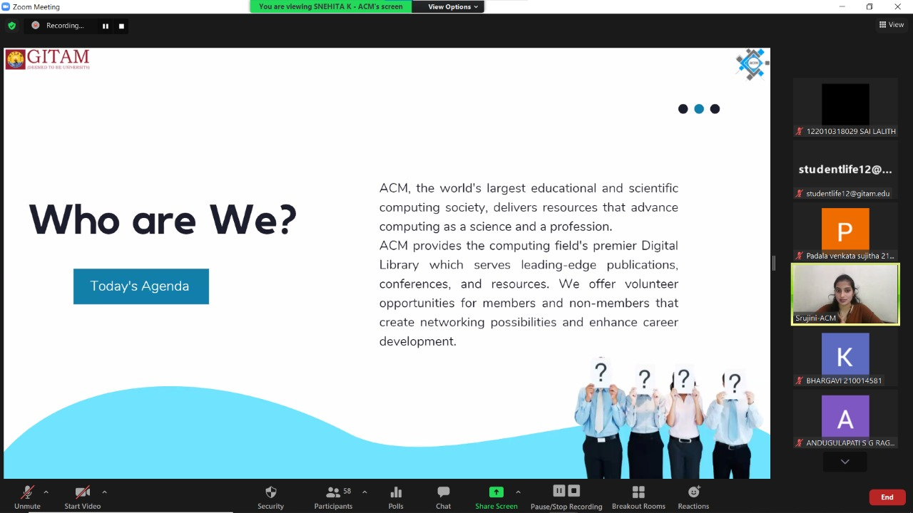

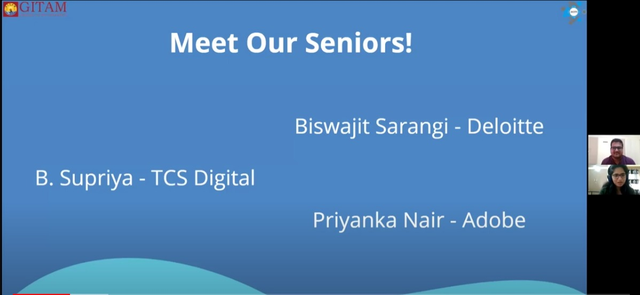

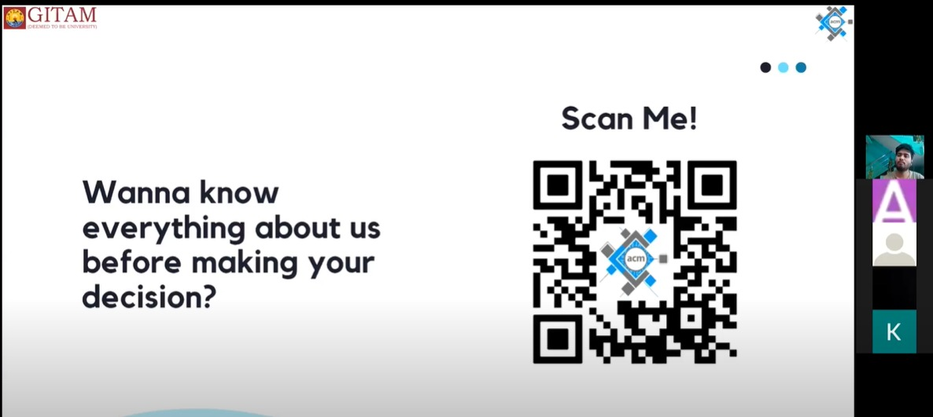

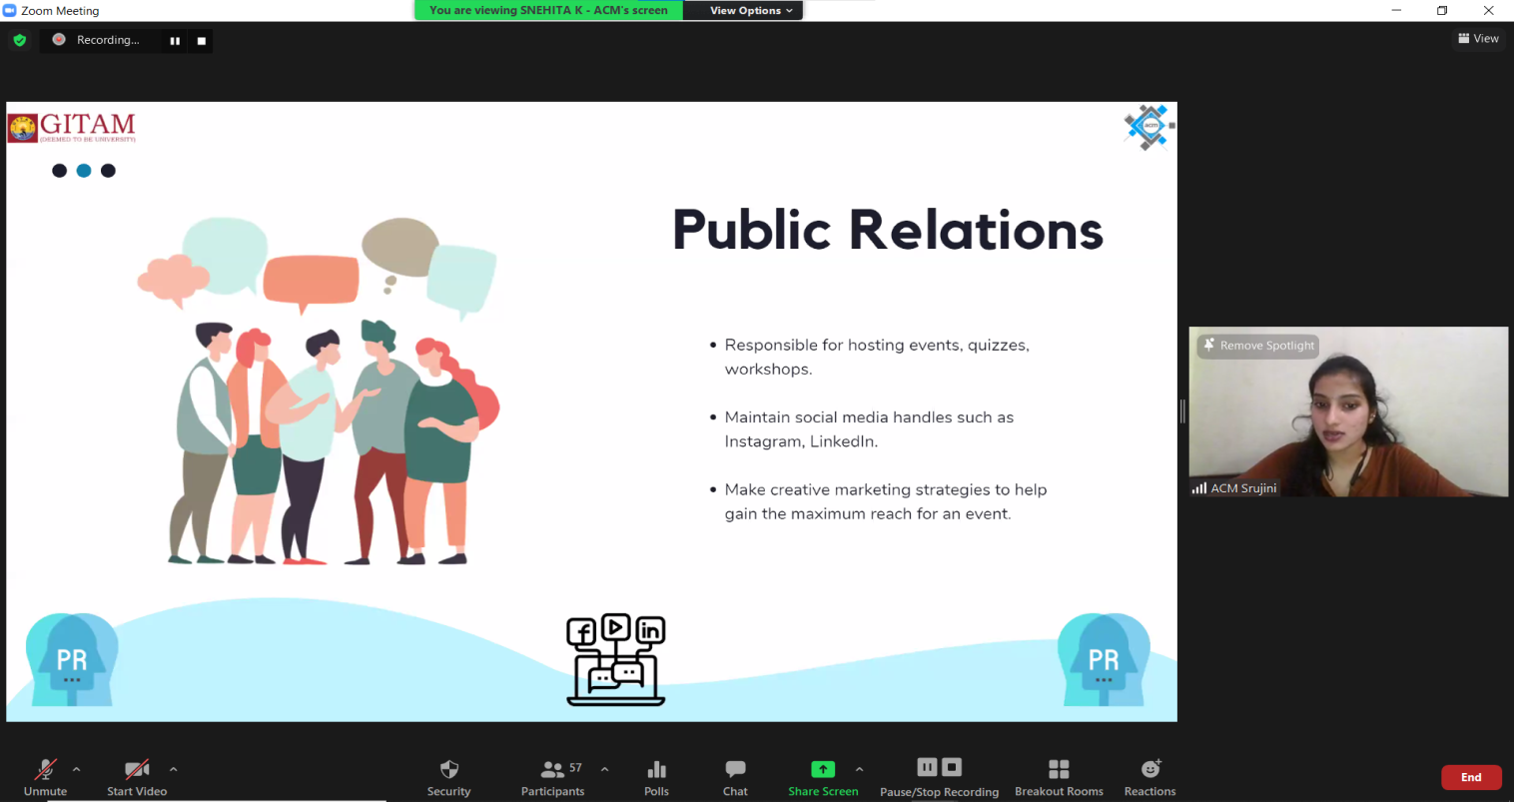

Event Snapshot

|  |  |
| --- | --- |
| **EVENTSNAPSHOT** | |
| Event Name: | Parichay |
| Organizing Club | ACM |
| Event Date: | 14/10/2021 |
| Event Time: | 11:00 AM to 11:40 AM |
| Event Mode/Venue: | Online/Zoom |
| Social media reach: | Instagram: 590 (from 523)  LinkedIn: 103 |
| Registrations: | 84 |
| Number of Participants/Attendees: | 58 |
| Winners (if any): Name - Regd ID – Email-ID | NA |
| Resource person: | NA |
| Event Report Author-Designation: | Snehita K.– Membership Chairperson,ACM.  GuruCharan-EventManagement Lead,ACM.  Abhishek D. -Event Manager, ACM.  Sravya B. - Event Manager, ACM. |